8.1

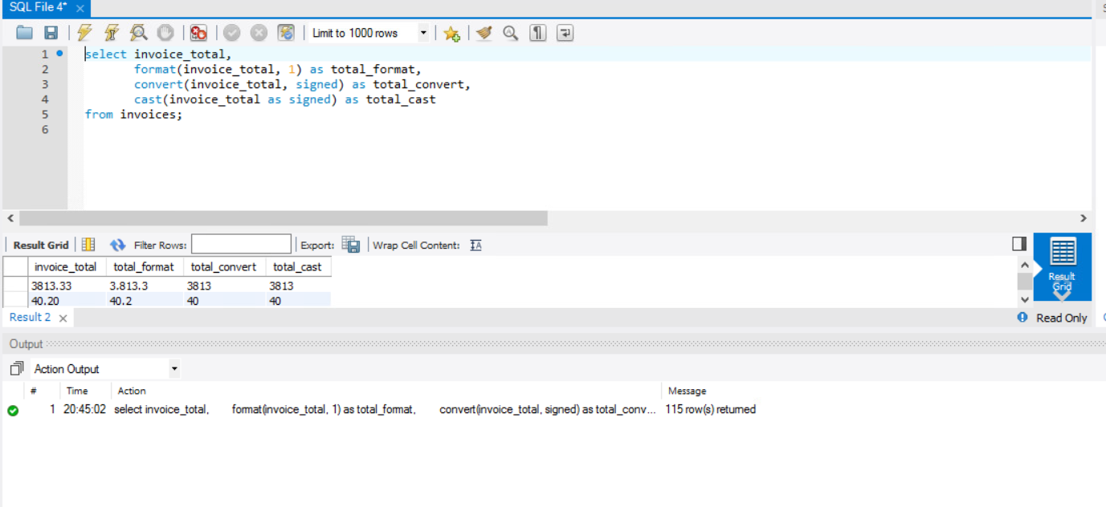

9.1

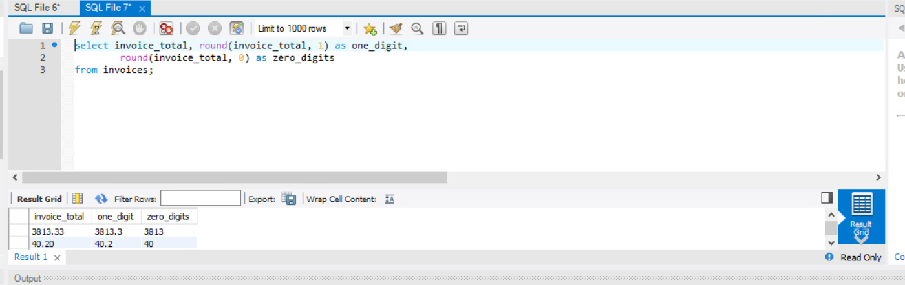

9.2

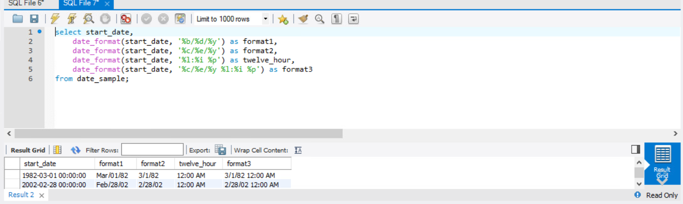

9.3

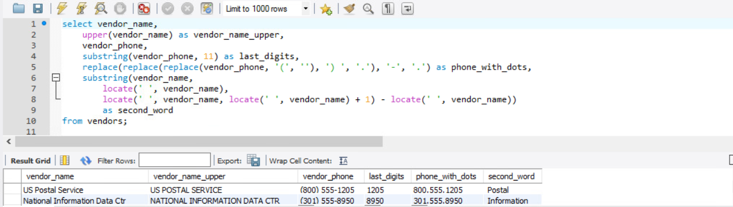

9.4

